LOGBOOK -9

1.



2.



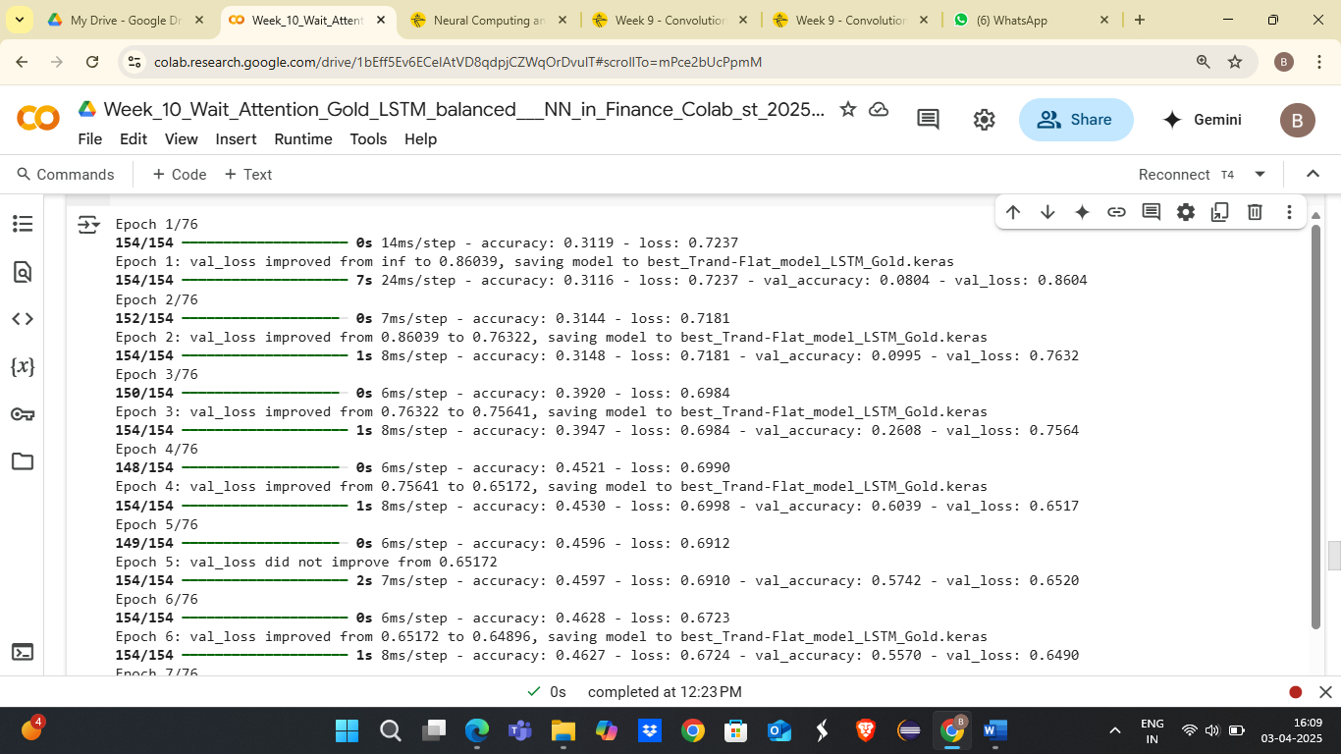

3. The resulting test Accuracy and other error metrics for the classification task using classification_report():

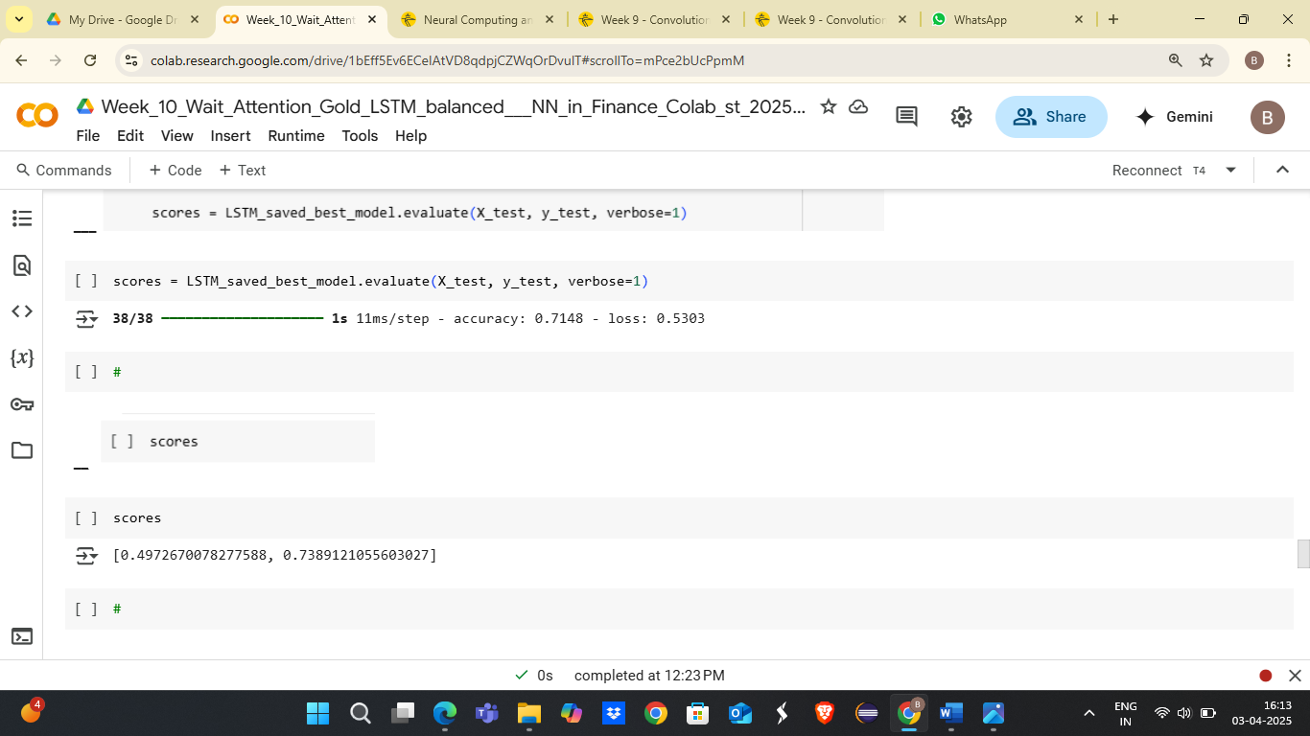

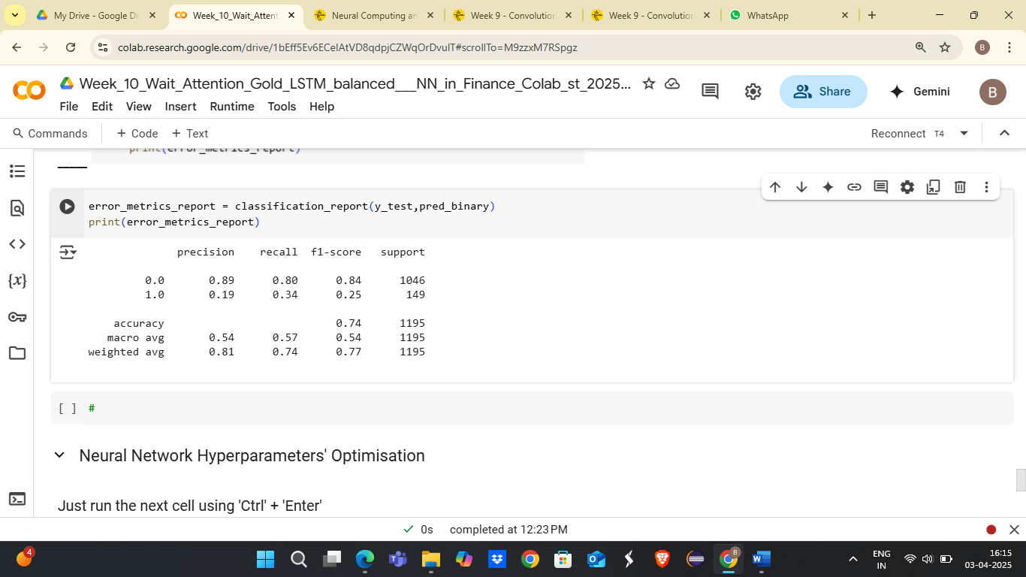

4. Accuracy detailed graph:

